PHISHING EMAIL DETECTION AND ANALYSIS OF REPORT
Introduction
Phishing email is one of cyberattack which is used to impersonate legitimate organizations to trick users to reveal sensitive information like userames,passwords bank creditionals,or personal informatioms. Phishing email often contains fake information and fake links which direct them to take their creditional and details easily.
The main objective of this assessment is to identify the fake emails, detect the phishing detectors, classify the risk levels and provide user recommendations to avoid these types of emails from phishing attacks.
Sample emails of phishing attacks
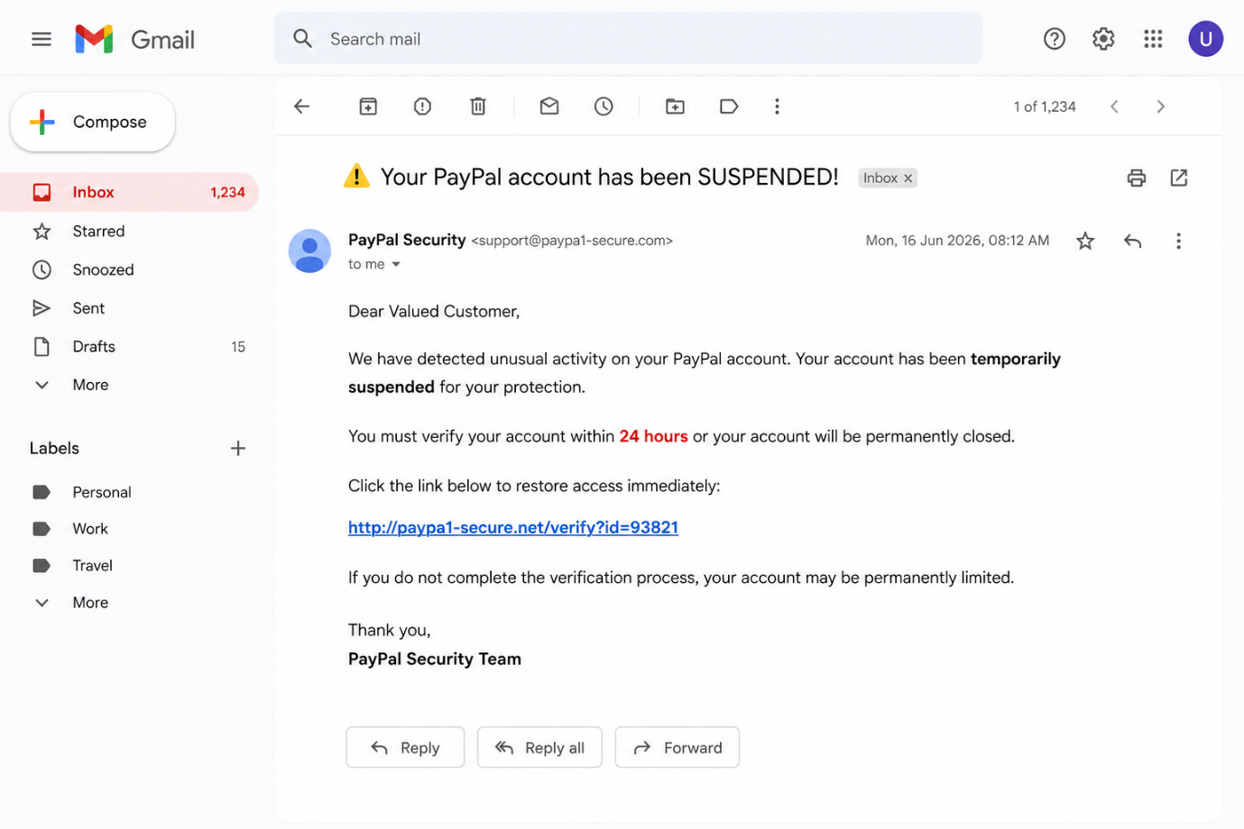
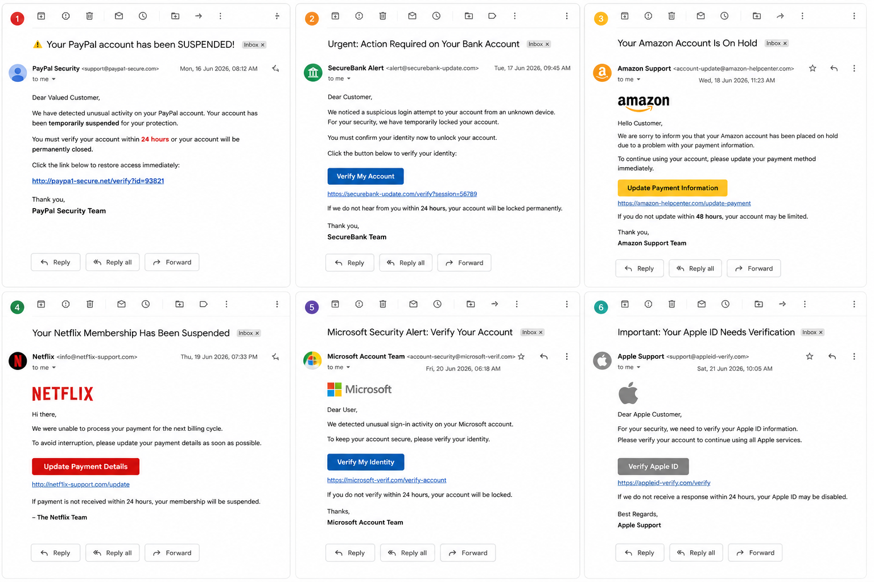


Header analysis
Header field | value | Observation
From | mailto:support@paypa1-security.com | Suspicious domain
To | customer@example.com | Genritic recipient
Subject | Your pay account has been suspended | Creates urgency
Date | Mon 16 june2026,08:12 AM | Normal format
Reply to | support@paypa1-security.com | Suspicious domain

Phishing Indicators
Fake Sender Domain
The sender domain uses:
paypa1-security.com
The number "1" replaces the letter "l" in "PayPal", making it look similar to the legitimate company.
Urgent Language
The email contains phrases such as:
- Action Required
- Immediate Verification
- Complete within 24 hours
Suspicious Link
The email contains the link:
http://paypal-security-check-example.com
This is not the official PayPal domain and may redirect users to a fake website designed to steal credentials
Risk Classification
Risk Factor | Observation | Risk Level | Reason
Sender Email Address | support@paypa1-secure.com | 🔴 High | Uses 1 instead of l in PayPal, indicating domain spoofing.
Subject Line | "⚠️ Your PayPal account has been SUSPENDED!" | 🔴 High | Creates urgency and fear to pressure the user.
Greeting | "Dear Valued Customer" | 🟠 Medium | Generic greeting instead of the recipient's actual name.
Hyperlink | http://paypa1-secure.net/verify?id=93821 | 🔴 High | Suspicious domain and uses HTTP instead of secure HTTPS.
Time Pressure | "Verify within 24 hours" | 🔴 High | Common phishing tactic to create panic.
Grammar and Style | Mostly professional but manipulative | 🟡 Medium | Professional appearance can deceive users.
Request for Action | Click link and verify account | 🔴 High | Attempts to redirect the victim to a fake website.
Brand Impersonation | Claims to be PayPal | 🔴 High | Uses a trusted brand name to gain credibility.

Prevention Recommendations
Users should follow these security practices:
- Verify the sender's email address carefully.
- Hover over links before clicking.
- Avoid entering credentials on suspicious websites.
- Enable Two-Factor Authentication (2FA).
- Report suspicious emails to the organization's security team.
- Delete phishing emails immediately.
Conclusion
The analysed email was identified as a phishing email because it contains several warning signs, including a fake sender address, a suspicious link, urgent language, and threats of account suspension. The attacker attempts to impersonate a trusted organization and create panic so that the recipient clicks the malicious link without verifying its authenticity.
This analysis demonstrates the importance of carefully checking the sender's email address, inspecting links before clicking, avoiding responses to urgent requests for personal information, and verifying messages through official websites. By recognizing these phishing indicators, users can protect themselves from identity theft, financial loss, and unauthorized access to their accounts.

